



Data Structures & Algorithm
LAB MANUAL

Disclaimer: The content is curated from online/offline resources and used for educational purpose only
Implementation of Binary Search Tree (BST)

Objective:
To implement a Binary Search Tree (BST) in Python and perform basic operations such as insertion, searching, and in-order traversal.

Equipment Required:
- Computer with Python installed, text editor/IDE.

Prerequisites:
- Understanding of binary trees
- Basic Python programming skills
- Familiarity with recursion
Problem Statement:
Implement a Binary Search Tree in Python with the following functionalities:
- Insert a node
- Search for a node
- In-order traversal

Procedure:
Step 1: Define the Node structure
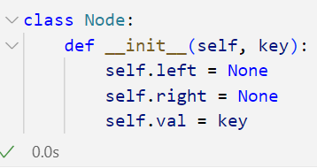

Step 2: Define the insert function
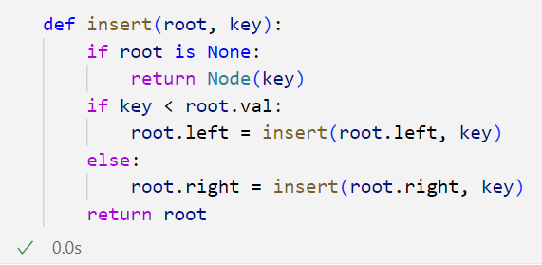

Step 3: Define the in-order traversal function
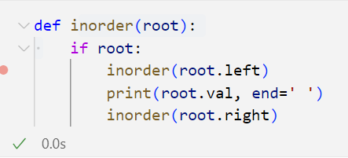

Step 4: Define the search function
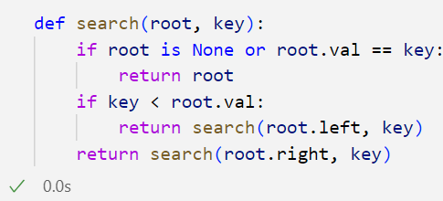

Step 5: The BST implementation
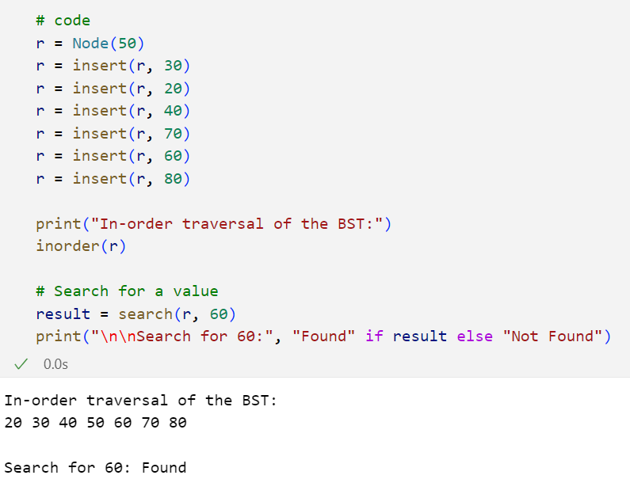

Output:
